Lab part B – Profile Construction
NAME:_______________________________________ Block:______________ Partner: ____________
Introduction:
A very useful exercise for understanding what topographic maps represent is the construction of a topographic profile. A topographic profile is a cross-sectional view along a line drawn through a portion of a topographic map. In other words, if you could slice through a portion of the earth, pull away one half, and look at it from the side, the surface would be a topographic profile. Not only does constructing a topographic profile aid in understanding topographic maps, it is very useful for geologists when analyzing numerous problems.

Map 1 – Rock Mountain
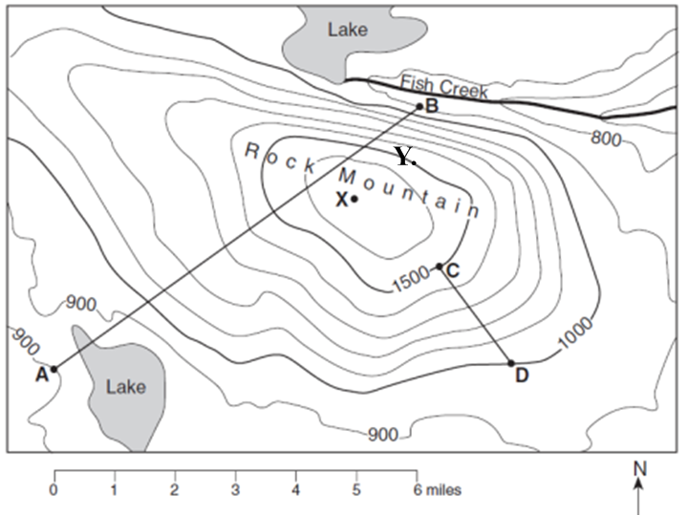

1. What is the contour interval for this map? _________feet

2. Use Map 1 – Rock Mountain map to construct a profile between line AB. The first and last point is done for you at 900 ft. If point B does not match up with B marked on your paper, simply write B at the correct location.

3. Determine which side (compass direction) of Rock Mountain has the steepest slope and explain how you can tell this by looking at the contour lines.

5. Which side of Rock Mountain would be the easiest to hike up? Explain your inference.

6. Calculate the gradient between points C and D (show ALL work and include units!)

Map 2 – Amethyst River
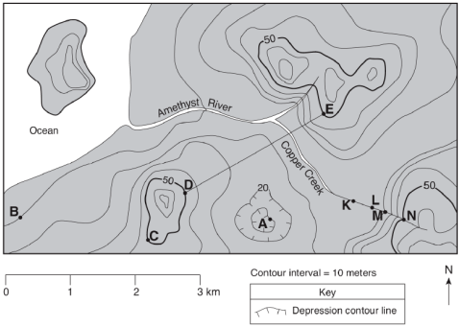
.Q

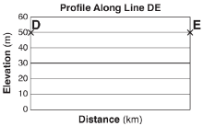
7. What is the contour interval for this map? ___________

8. Construct a profile between points DE.

9. By using your ESRT, calculate the gradient, to the tenths place, between points B and C. Be sure to write original formula, show substitutions with units, and box in answer with units.

10. Towards which compass direction is Copper Creek flowing between points N and K? ______________

11. What are elevations at the following points? (note that some points have acceptable ranges in values).

A. ______________ M. ________________ Q. ______________ K. _______________

12. What is the highest possible elevation that Amethyst River could start? _______________________

13. Is Copper Creek flowing faster between points M and N or points K and L? Explain how you can tell.

Map 3 – Patty Hill
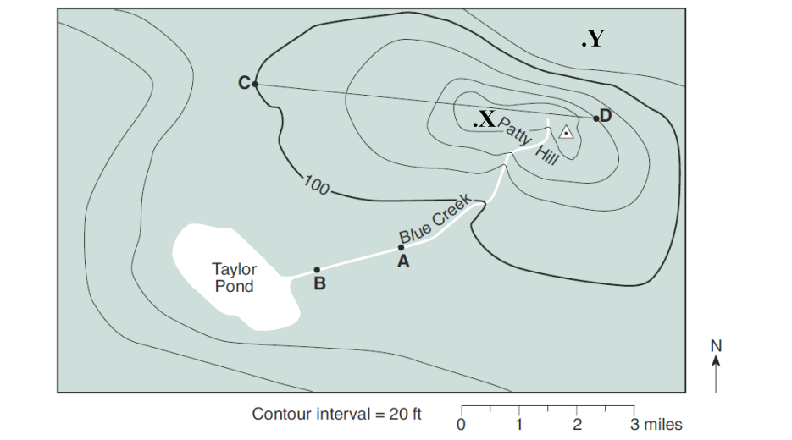

.

14. What is the contour interval for this map, include units? _____________________

15. By using Map 3 – Patty Hill map to construct a profile between points C and D. .

16. By using your ESRT, calculate the gradient, to the tenths place, between points C and X. Be sure to write original formula, show substitutions with units, and box in answer with units.

17. By using your ESRT, calculate the gradient, to the tenths place, between points X and Y. Be sure to write original formula, show substitutions with units, and box in answer with units.

18. Compare the gradients between points C and X to points X and Y.

Map 4 – Mud Creek
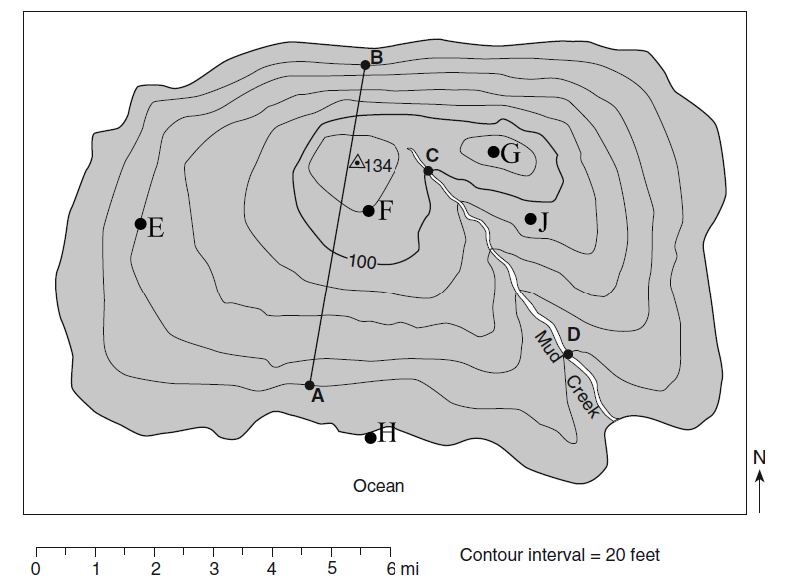

19. By using Map 4 – Mud Creek map to construct a profile between points A and B. Line up point A to point A and if point B does not hit B it is ok.

20. Without creating a scaled profile, draw an image in the box below that would show how the topography of the land would change from points H to J (estimate a profile). What geographic feature did you cross along the way?
J
H

